**African Journal for Social Transformation**

[**https://journals.tangaza.ac.ke/index.php/AJST**](https://journals.tangaza.ac.ke/index.php/AJST)

**ISSN Online: 2958-0447**

**Amaya Triangle Peace Index Report**

Joshua Davis ([josh@csi-kenya.org](mailto:josh@csi-kenya.org))

Isaiah Lekikunit ([isaiah@csi-kenya.org](mailto:isaiah@csi-kenya.org))

Mark Leleruk ([consult@csi-kenya.org](mailto:consult@csi-kenya.org))

**Abstract**

The conflict tracking reports from the fourth quarter of 2023 and the first quarter of 2024 provided hope for the work Community Safety Initiative-Kenya (CSI-K), backed by its partners, is achieving in the Amaya Triangle. Overall, we saw a 42% decrease in conflict across the two conflict-reporting counties of Laikipia and Samburu. Utilizing our conflict identification methodology, we have created an effective means of understanding instances of different types of conflicts. This style of data reporting enables us to conduct a chronological comparative analysis and examine any of type of conflict, conflict locations, or interventions across quarters. Here, we have primarily examined the fourth quarter of 2023 to the first quarter of 2024. However, we extended our purview to include reported conflict starting in January of 2023 to get a broader picture of the relative peacefulness of the Amaya. This analysis found out that conflict generally declines within the Amaya Triangle. There was a decrease in CI (conflict incidence) reports from all regions. This information would help support more refined data gathering for future Peace Index Reports, stakeholder progress reports, and CSI-K programming.

**Keywords**: Amaya Triangle, Conflict Analysis, Samburu, Laikipia, Negative Peace

**How to cite this paper:** Davis, J., Lekikunit, I. & Leleruk, M. (2025). Amaya Triangle Peace Index. *African Journal for Social Transformation, 1(3), 1 – 17.*

**Corresponding author:** Joshua Davis ([josh@csi-kenya.org](mailto:josh@csi-kenya.org) )

**Introduction**

The focus of the research is three-fold. First, it is essential to understand the effectiveness of Community Safety Initiative-Kenya’s (CSI-K) programming within the Amaya triangle. We met this broad goal by tracking general Conflict Incident(s) (CIs) across the region of the Amaya Triangle Counties (ATC), containing the counties of Samburu, Laikipia, and Baringo. The data helps identify where CSI-K and its resources are most needed. By examining a geographic breakdown and types of conflict, we can better understand what is happening and where it is happening and curtail programming to solve specific issues in specific areas.

The second primary goal of this research is to be able to report to the CSI-K funders, stakeholders, and partners. These include, but are not limited to the county governments of Samburu, Laikipia, and Baringo, the United States Agency for International Development, the United Kingdom Department for International Development, the Danish Embassy, and the civilian populations of the ATC.

Finally, CSI-K wants to add to the academic literature around conflict. To do this, provide a replicable tool for understanding peacefulness. Quantifying “peacefulness” is an empirically difficult task. To best account for this, we are examining the prevalence of “negative peace” as described by Johan Galtung (1969). “Negative Peace” is the absence of violent conflict. To that end, we have created a means of tracking and analyzing the prevalence of violent conflict we envision can be used in most contexts.

*Note: Baringo Disclaimer*

As our data set demonstrated, CSI-K has not recorded any incidents within the county of Baringo. It is unlikely that Baringo does not see *any* violent conflict between pastoralist tribes. In future iterations of this peace report, utilizing an updated format for conflict recording and striation, we will better grasp the conflict of the Amaya triangle.

**Counties Overview**

*Figure 1: Map of Amaya Triangle Counties*

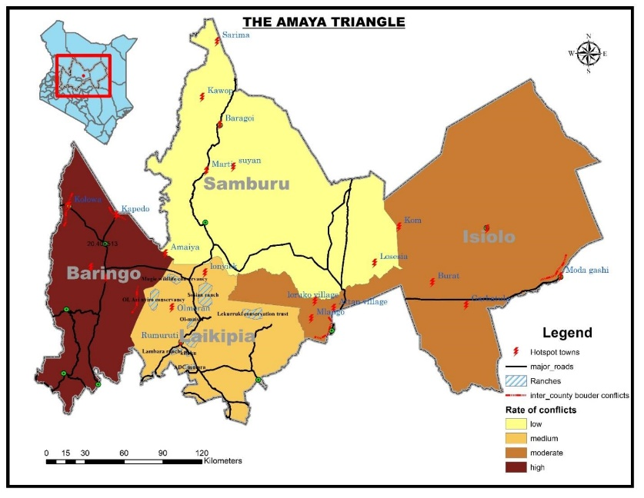CSI-K has been operating in the ATC since 2019. Local pastoral communities, including the Pokot, Samburu, Laikipia Maasai, Turkana, and several other minority tribes, inhabit the three counties. The three counties are among the members of the economic bloc referred to as Cooperation for Peace and Development (CoPaD), with CSI-Kenya as the leading partner in peace and security. The three counties are also members of other critical economic blocs in the region, including the North Rift Economic Bloc (NOREB) and Frontier Counties Development Council (FCDC).

*Figure 2: Map of Samburu County*

***Samburu County***

Samburu County is located at (0030ˋ-2045ˋN and 36015ˋ-38010ˋE). The county lies within Kenya's arid and semi-arid land (ASAL) and covers about 21,090 square kilometers. During the last official Kenya Population and Housing Census (KPHC 2019), Samburu County had 310,327 persons and an annual growth rate of 3.0% against a national growth rate of 2.0%, an indication that the county needs a commensurate expansion of economic investment to ensure a resilient local community in the middle of the changing climate and need to stay on race with the rest of the global community. The main economic activity is pastoralists’ livelihood at 80 percent, a feeble economic activity in the center of cyclical and protracted droughts brought about by climate change.

Samburu County has three sub-counties, seven divisions, 39 locations, and 108 sub-locations. Among its 15 wards, Suguta Marmar, Loosuk, and Angata Nanyekie benefit from CSI-K Kenya peace interventions to alleviate conflict drivers. The three wards are particularly conflict-torn areas in the County. Table 1 below shows the breakdown of the county's population per sub-county.

*Table 1. The population of Samburu County by sub-county (source: Kenya NBS Census)*

| Sub-County | Population | Household | Household size |
| --- | --- | --- | --- |
| Samburu Central | 163,942 | 34,202 | 4.8 |
| Samburu East | 77,136 | 18,424 | 4.2 |
| Samburu North | 68,879 | 13,284 | 5.0 |
| **Total for County** | **307,957** | **65,910** | **4.7** |

*Figure 3: Map of Baringo County*

***Baringo County***

Baringo County is one of the largest counties in Kenya, covering 11,075 square kilometers but with a relatively small population compared to other counties. It is between longitudes 35 30’ and 36 30’ East and between latitudes 0 10’ South and 1 40’. The Equator cuts across the County in the southern part. KPHC- 2019 indicated the county’s population is 666,763 and disaggregated by gender as 336,322 males, 330,428 females, and 13 intersex.  The Kalenjin sub-tribes of Tugen and other communities such as Pokot, Ilchamus, Endorois, Kikuyu, Turkana, and the Nubians are the chief inhabitants of the County.

The county is administered through 7 sub-counties: Baringo South, Mogotio, Eldama Ravine, Baringo Central, Baringo North, Tiaty West, and Tiaty East. The county has 30 divisions and 116 locations. The population by sub-counties is indicated in table 2 below.

*Table 2. The population of Baringo by sub-county. (Source: Kenya NBS Census)*

|  |  |  |  |
| --- | --- | --- | --- |
| Sub-County | Population | Households | Household size |
| Baringo Central | 96,195 | 23,555 | 4.1 |
| Barngo North | 104,654 | 23,500 | 4.5 |
| East Pokot | 79,770 | 14,498 | 5.5 |
| Koibatek | 128,874 | 30,774 | 4.2 |
| Marigat | 89,210 | 19,854 | 4.5 |
| Mogotio | 90,911 | 18,184 | 5.0 |
| Tiaty East | 73,146 | 12,153 | 6.0 |
| **Total for County** | **662,760** | **142,518** | **4.7** |

Baringo County's main economic activity is agriculture, accounting for 58% of the GDP. The lowlands of the County are characterized by dry landscape and high temperatures, with livestock keeping as the main economic activity. In recent years, Baringo County has experienced various challenges, such as climate change and its impact on resource-based conflict, which have continued to ravage the County with increasing intensity and frequency. Insecurity in the form of vicious cattle rustling, banditry, and highway robbery is prevalent in the County. Decisive and swift action is desperately needed. A multifaceted approach to addressing Baringo's longstanding menace of insecurity can resolve this challenge. The notable conflict hotspots in the County are on its borders with its neighbors. Some notorious hotbeds of the conflict are Makutani, Arabal, Mochongoi, and Chemorongion.

The available statistics state that the County’s overall poverty rate is 39.6, with 8.5% of the population living in extreme poverty, against overall national rates of 36.1 and 8.6%, respectively. The poverty status is relatively associated with the myriads of natural calamities that have befallen the county and stagnated development.

*Figure 4:. Map of Laikipia Country*

***Laikipia County***

Laikipia County covers an area of 9,462 square kilometers and is ranked as the 15th largest County in the Country by land size. It lies between latitudes 0° 18” South and 0° 51” North and between longitudes 36° 11” and 37°. It borders Samburu County to the North, Isiolo County to the North East, Meru County to the East, Nyeri County to the South East, Nyandarua County, and Nakuru County to the South West and Baringo County to the West. It comprises of six administrative sub-counties (the Constituencies): Laikipia East, Laikipia North, Laikipia West, Laikipia Central, Nyahururu and Kirima sub-county. The county’s administrative headquarters is in Rumuruti. The County is further subdivided into 16 divisions, 57 locations, and 115 sub-locations.

The ethnic communities in the County are the Kikuyu, Maasai, Samburu, and Kalenjin (Pokot, Tugen, Nandi, and Ogiek / Dorobo). The 2019 National Housing Census established that Laikipia’s population was 518,560, equivalent to 1.1 percent of the national population (KNBS). There were 259,440 males, 259,102 females, and 18 intersex people in the county. Population per constituency is shown in table 3 below.

*Table 3: Population of Laikipia County by sub-county  (source: Kenya NBS Census)*

|  |  |  |  |
| --- | --- | --- | --- |
| **Sub-County** | **Population** | **Households** | **Household Size** |
| Laikipia Central | 95,281 | 30,372 | 3.1 |
| Laikipia East | 100,874 | 33,505 | 3.0 |
| Laikipia North | 35,870 | 7,752 | 4.6 |
| Laikipia West | 128,693 | 33,025 | 3.9 |
| Nyahururu | 153,161 | 44,617 | 3.4 |
| **Total for County** | **513,879** | **149,271** | **3.4** |

The main economic activities in the County include ranching, crop farming, dairy farming, tourism, and trade. The main crops grown include wheat, maize, beans, potatoes, and vegetables. The main livestock types are cattle, goats, sheep, and poultry. Major tourist attractions in Laikipia include wildlife, the unique Maa-speaking cultural practices, the Thomson Falls, as well as proximity to Mt. Kenya, Meru, Aberdares, and Samburu game parks (Laikipia CIDP 2023 – 2027).

According to the Laikipia County Integrated Development Plan 2023 – 2027, Insecurity has been a significant challenge for the county for a long time. The plan attributes this to banditry and cattle rustling from the neighboring counties of Isiolo, Samburu, and Baringo as they cross into the county searching for pastures during dry spells. The plan suggests that these incursions have been major causes of inter-ethnic tensions, resulting in frequent tribal clashes, which lead to displacements, loss of life, and property.

**Methodology**

In order to best understand the regions, we began by conducting baseline analyses of the Amaya Triangle counties, Samburu, Baringo, and Laikipia. This data was obtained from Kenyan government publications, including Census data, memorandums from the Cooperation for Peace and Development, North Rift Economic Bloc, and Frontier Counties Development Council, as well as additional data from County Integrated Development Plans.

Following the collection of information on the geographic regions, we designed our process of data collection and interpretation. This being the first iteration of an Amaya Triangle Peace Index, this process was unorthodox. Previously, CSI-K collected conflict reports from community members and national security agencies and compiled them into a spreadsheet. When creating a more formal data collection process, CSI-K looked at all conflict reports from January 2023 to April 2024 for broad trends and ways to best classify the data. Broad categories such as location, conflict type, intervention, and fatalities were collected; we have broken down the data into categories to ensure an ability to quantify and examine trends. We retroactively implemented the previously compiled data for Q4 2023 and Q1 2024 into our reporting tool. This does not discredit the new reporting method, as the variables were created based on the data gathered.

**Considered Variables**

1. *Place of Incident*

This variable was collected to allow geographic and chronological comparisons. The individual or organization reporting the CIs collects the variables via a Google Forms reporting sheet. Date information is collected in MM/DD/YYYY format.

The place of incident is reported in three parts: “place of incident,” “County,” and “Sub-County.” They are self-reported. The place of incident refers to the town, village, municipality, or ward closest to the conflict sight. It is used to provide further geographic specifications for violence. We have restricted the scope of the research to the counties within the ATC: Samburu, Laikipia, and Baringo. Sub-county refers to North Samburu, East Samburu, West Samburu, South Samburu, or Central Samburu, and we repeat this distinction for the counties of Laikipia and Baringo. The County is selected by multiple-choice, and Sub-County is filled using the County-Cardinal Direction/Central template.

We track the County data to analyze inter- and intra-county conflict further. This data allows us to examine the effectiveness of County governments and see which County resources should be allotted.

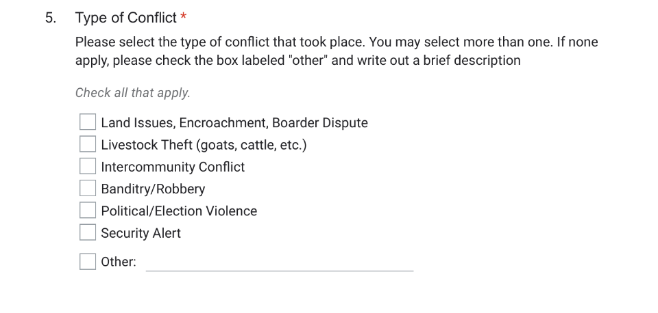

1. *Type of Conflict*

The types of conflict reported are broken into five categories: Land Issues, Encroachment, Border Dispute, Livestock Theft (goats, cattle, etc.), Inter-community conflict, Banditry/Robbery, Political/Election Violence, and Security Alert.

We have also included an “other” fill-in option for instances of conflict not covered by these archetypes. The CSI-K team identified this variable as the most valuable way to understand and document types of violence in the ATC. Further explanation of the variables is provided below.

*Land Issues, Encroachment, Border Dispute*

We created this archetype to include any instances of attempted land grabbing between conflicting parties. These include attempts by pastoralist tribes to encroach on the grazing lands of other ethnic communities, private ranches, and nationally protected lands.

*Livestock Theft (goats, cattle, etc.)*

This archetype was created to include any attempts by conflicting parties to steal livestock from one another.

*Intercommunity Conflict*

For this purpose, intercommunity conflict is defined as a non-resource-based conflict. It may involve retaliation killings between ethnic communities, attacks on security agencies, or preemptive attacks against suspected war/raiding parties.

*Banditry/Robbery*

These conflicts occur when an object(s) or money is stolen by one conflicting party from another. They include attempted robberies halted by external intervention and robberies of stores or individuals/groups. All conflicts of this type result in some non-living, tangible possession being taken from an owner or attempted to be taken from the owner. It was essential to differentiate this from livestock theft, as theft within cities such as Maralal seldom included the stealing of animals.

*Political/Election Violence*

Political/Election violence includes any conflict that causes or results in the death of a public figure or political institution/project. These conflicts often lead to specific government interventions or responses and may have different motivations. Therefore, it is essential to differentiate these from inter-community conflicts.

*Security Alert*

This conflict type refers specifically to instances where a conflict seemed likely to occur and was reported but did not come to fruition. Either intervention by chiefs, county leaders, security agencies, or another actor deterred a conflict from occurring. These are important to track as a decrease in other types of conflict. Still, an increase in security alerts may support claims of the effectiveness of CSI-K’s efforts to implement early warning systems.

1. 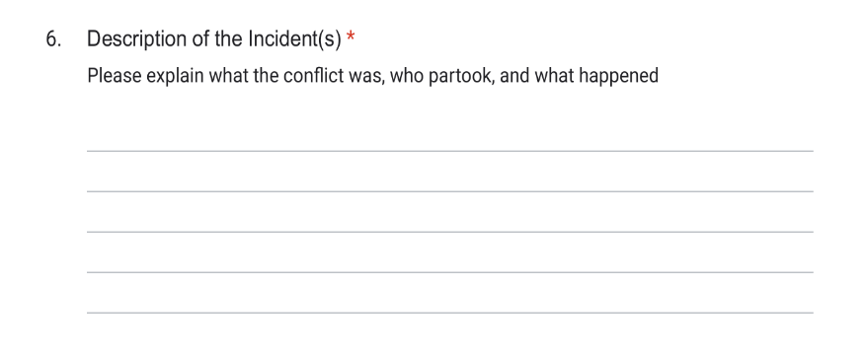*Description of the Incidents*

It is essential to understand the story of a conflict. This was our effort to avoid diluting conflict to numerical statistics and include an account of what happened. We investigated this in the form of an open ended question.

1. 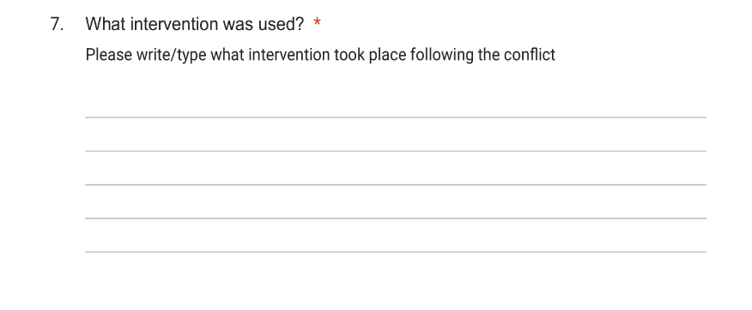*What Intervention was used*

This variable is another open-ended response question used to understand who, if anyone, got involved in the conflict. This could include community members engaging in a dialogue, peace marches after political violence, or security agencies pursuing culprits. It is meant to understand the attempts at conflict resolution or prevention going forward.

1. 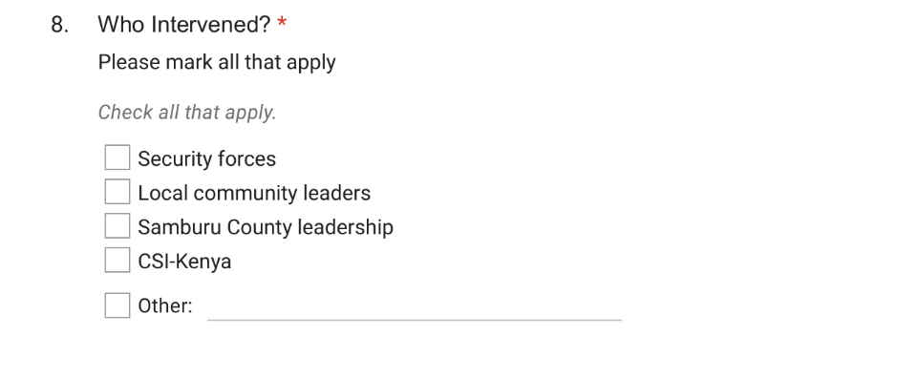*Who Intervened*

This variable consists of a “select all that apply” approach to gathering data on who participates in the interventions. The possible responses include Security Agencies (these include sub-county security teams, Deputy county commissioner (DCC), assistant county commissioner (ACC), directorate of criminal investigation (DCI), national police reservists (NPR), and community conservancy security), local community leaders’ Samburu County leadership, CSI-K, and Others/fill-in. As with the Conflict Types question, multiple interveners can be reported.

1. *Number and Type of Livestock Stolen*

These two are reported separately for ease of calculating the total number of livestock stolen. Understanding how many livestock were stolen is essential, as long-term trends may indicate increased desperation, need, or potential retaliation attacks. These are recorded by asking for a fill-in number of livestock stolen and type (goats, cattle, camel, shoats, etc.) as two separate questions.

1. *Number of Fatalities*

This statistic is used to track the severity and deadlines of conflict. This is recorded by choosing a number 0-5 with an option for other if more than 5.

**Results**

This study saw a notable decline in conflict incidences between the end of 2023 and the beginning of 2024. Below is a listing of general conflict, followed by divisions into conflict by county and then by conflict type.

In the ATC, there were 19 CIs in Q4 of 2023 and 7 in Q1 of 2024. This was a 50% decline in livestock theft between the two quarters. There was also a decrease in the number of unlabeled conflicts, from five to zero. There was also one less instance of political/election-based violence,

and the number of inter-community violence (2), robberies/banditry (2), or security alerts did not change over the six months. The graph below illustrates this.

*****Conflict by County***

***Laikipia County***

Conflict in Laikipia County saw a stark decrease from Q4 to Q1, from five CIs of two livestock thefts and three other types to only one livestock theft. All CIs during this timeframe took place in Laikipia North sub-county. Q4 saw three fatalities and a total of 317 livestock stolen and 217 recovered. Q1 had 0 fatalities and 200 livestock stolen. None of the stolen livestock were reportedly recovered.

***Samburu County***

Conflict in Samburu County also declined over the examined period. There were 15 reported incidents in Q4 2023 and 7 in Q1 2024. This decrease was most evident in the steep decline in Livestock Theft, Political/Election violence, and “other” CIs. Most of the conflict in both quarters was in Samburu Central (7 in Q4 and 4 in Q1). In Q4 of 2023, there were 11 fatalities, a minimum of 387 livestock stolen, and none recovered. In Q1 of 2024, there were four fatalities, an unknown number of livestock stolen, and none no recovery was reported.

*Important Note: Samburu Central*

While conflict has been decreasing, Samburu Central’s share of CIs has grown from ~40% in Q4 of 2023 to ~60% in Q1 of 2024. This indicates a region with an opportunity for more engagement and reevaluation of CSI-K activities.

**Annual Analysis**

The primary trend is that when looking at CIs as a whole over these two quarters, the Amiaya Triangle region, specifically the countries of Samburu and Laikipia, are becoming more peaceful. This is further supported when examining conflict dating back to Q1 of 2023. We see a gradual decrease over time. Below is a graph showing the number of CIs over the past 15 months.

**Future Steps**

Our analyzed data indicates a decrease in violent conflict, indicating an increase in negative peace within the region. This decrease was seen across all sub-counties with reported data and across all types of conflict. Comparing Q4 of 2023 to Q1 of 2024, independent of other data, brings a reasonable doubt that other factors such as time of the year may be indicative of this decrease. However, when accounting for the annual analysis, it becomes evident that conflict as a whole has decreased.

1. ***Informed next steps for Future Research***

The priority is altering and formalizing our data collection system. The new form and variable descriptions outlined above are the first step in this process. With this form, we will be able to reach more population, specifically recognizing we had no data from Baringo County. With a more refined process of data examination, we hope to expedite the entire process of understanding conflict. We also hope to use this document as a template to complete further quarterly analysis of peacefulness. Finally, we will create annual reports to provide a wider picture of the effectiveness of our programming akin to the “Annual Analysis” section in this report.

We are also planning to roll out a second phase of research to track overall peacefulness using qualitative methods. We plan to conduct a series of interviews with community members to contrast the quantitative data given to us by CIs with a qualitative check for the same dat. This will provide further insight into the causes of conflict. In future publications, we will include both quantitative and qualitative data.

***ii) Informed Next Steps for Partners***

We plan to improve and build both the academic research and practical peace-building arms of CSI-K. This study was conducted to examine the current state of peacefulness in the Amaya Triangle and assess the efficacy of CSI-K programming. To continue the mission of this document, below, we outline what paths are being taken to improve our research and contribute to peace-building.

**CONCLUSION**

CSI-K’s work is theoretically informed by Galtung’s writing on negative and positive peace, recognizing it is important to see a cessation of violence (negative peace) and sustained social change (positive peace). We look to achieve this positive peace through what Lederach describes as “conflict transformation” or the importance of dialectic conflict resolution, understanding the narrative of both sides and moving away from a “good guy vs. bad guy” binary. Our work is also informed by the United Nations Sustainable Development Goals (SDGs), specifically 8, 10, and 16. These two theoretical pillars, a mandate from the United Nations, and a newfound commitment to analytical research, have informed the creation of our programming goals: building the capacity to immediately address conflict as it erupts and engaging in lobbying to produce structural changes to minimize the need for conflict.

*Capacity Development*

CSI-K's peace-building and conflict management programs are designed to strengthen the capacities of peace-building structures at the community level. We accomplish this with a twofold approach. First, to promote negative peace, community dialogues, and peace reporters should be created to address conflict as it arises. Second is by providing concrete educational material to combat illiteracy, gender bias, and ethnic-centrism to build sustainable positive peace. In addition to promoting decreased violence, we aim to incentivize peace and stability by continuing dialogue around economic prosperity.

Examples of institutions strengthened to achieve this milestone include Peace Committees, Water Resource Users Associations (WRUAs), Grassing Committees, and State and Non-State Peace actors, including the National Police Service (ASTU, NPR, Administration Police, County Administrators, and Civil Society Organizations). CSI-K must ensure that strong peace-building institutions are put in place with global standards of justice and to enhance peace everywhere.

*Legislative and Policy Framework and Peace-building Responsive Budgeting*

As we have identified, most CIs are instances of resource conflicts, we have sought to find ways to minimize or eliminate the problem of resource scarcity. CSI-K, in partnership with peace actors in the ATC, has backed a policy framework with Laikipia, Samburu, Isiolo, and Baringo counties to promote sustainable resource management in Northern Kenya and to enhance the resilience of pastorals' communities to climate change encompassing the following strategies:

1. Pastoral communities in the Laikipia, Samburu, Isiolo, and Baringo counties engage county authorities on legislation and practices that support improved range-land management to avoid over-grazing.
2. Policy Advocacy and Lobbying Samburu County Government to develop legislation, policies, and frameworks on natural resource management focusing on marginalized community groups, including women, youth, and people with special needs.
3. Established economic and political empowerment networks with Frontier Counties Development Council (FCDC) and ATC member counties to set up a Peace and Cohesion Sector Forum that will lead the development of strategies to address resource-based conflict and women empowerment opportunities aimed at addressing gender equality in the Amaya Triangle and the FCDC Counties.

**ACKNOWLEDGEMENTS**

***Mercy Corps***

Recently, Mercy Corps and CSI-K signed a Memorandum of Understanding (MoU) to solidify partnership, networks, and collaboration to leverage the peace-building and conflict management efforts in Amaya Triangle under the following pillars:

1. Resource Governance and Range-land Management:
   1. This intervention plan aims to tackle the scarcity of resources. First is promoting good governance and leaders around range-land management to promote sustainability and minimize resource scarcity. The second is to promote access and utilization of the Community Land Act and its Climate Change Financing to mitigate adverse impacts of climate change, such as drought and floods. The plans are as follows:
2. Incorporate environment management and restoration strategies in programming and supporting communities and institutions to address collective environmental challenges associated with disasters by incorporating disaster risk reduction strategies (DRR), including preparedness, adaptation, and transformation of livelihoods.
   1. Support environment management and restoration policy frameworks to inform sound decisions to secure a healthy ecosystem.
   2. Strengthen community and institution capacities to address emerging threats to environment and range-land management.
   3. Promote conservation and sustainable commercial usage of natural resources and their products.
3. Livelihood Resilience Projects:
   1. To focus on the long-term resilience of communities affected by climate change shocks, CIS, in partnership with Mercy Corps, will continue to support marginalized groups, targeting women and youth, to enhance their economic status and participation in decision-making in a goal to foster gender equality in leadership and political spheres. These interventions included:
      1. We support women, youth, and vulnerable groups in tapping into cooperative funding for business and social-economic development and skill development in resource mobilization to fund their initiatives.
      2. Train and support women, youth, and vulnerable groups in developing business plans, link them with financial lending institutions for loans and acquisition of funding, and support them in exploring alternative forms of compatible livelihoods.
      3. Establish linkages and networks for marketing the group's IGA products to maximize profit and suitability of their enterprises for viable value chains in the ATC.

***Institute for Social Transformation, Tangaza University***

The proponent of this institution's ideology is pegged on "the Regeneration of Africa by Africans" - compounding the essence of CSI-K's communities' empowerment interventions to ownership - that communities have the power to manage and own their development initiatives.

In partnership with Tangaza University, CSI-K aims to promote a Peace Education Research Program in the region to enhance progressive formal and informal peace education opportunities. This program is key to having a Data Management portfolio for programming projects and informing decisions for policy development, implementation, monitoring, and evaluation for knowledge harvesting and management. Strategic approaches will encompass data collecting, processing, validation, and dissemination.

**USAID Nawiri**

The USAID Nawiri program, named from the Swahili word for “thrive,” is an 8-year flagship initiative funded by USAID Bureau of Humanitarian Assistance (BHA) with the overarching goal of sustainably reducing levels of persistent acute malnutrition in Kenya’s arid and semi-arid lands (ASALs). Recognizing the need for local, context-specific, and sustainable solutions to the complex development problem of persistent acute malnutrition in Kenya’s ASALs, BHA is providing multi-year support for USAID Nawiri. It recognizes the need to address underlying causes of acute malnutrition through an integrated, multi-sectoral activity that leverages ongoing emergency and development activities. A key objective of USAID Nawiri is to prepare local systems and institutions to assume financial and technical responsibility for the implementation of nutrition programming in the future. USAID Nawiri is a strong partner of CSI-K’s work and prominent stakeholder in this research.

**References**

*Galtung, Johan. “Violence, Peace, and Peace Research.” Journal of Peace Research, vol. 6, no. 3, 1969, pp. 167–191*

County Government of Baringo, Office of the Governor. (2023) “Baringo County Integrated Development Plan (2023-2027). <https://www.baringo.go.ke/resource/cidp-2023-2027-popular/?tk=NjQwMA==>

County Government of Laikipia, Office of the Governor (2023). “Laikipia County Integrated Development Plan 2023-2027. <https://repository.kippra.or.ke/bitstream/handle/123456789/4335/COUNTY%20GOVERNMENT%20OF%20LAIKIPIA%20-%20COUNTY%20INTEGRATED%20DEVELOPMENT%20PLAN%202023-2027%20%20Final%20Version%20-%20Finalised%2006102023%20-%20for%20print.pdf?sequence=4&isAllowed=y>

County Government of Samburu, Office of the Governor (2023). “Samburu County Integrated Development Plan 2023-2027. <https://repository.kippra.or.ke/bitstream/handle/123456789/4522/SAMBURU-COUNTY-_-CIDP-2023-20271.pdf?sequence=1&isAllowed=y>

Kenya National Board of Statistics. “Kenya Population and Housing Census Reports” 2019 <https://www.knbs.or.ke/2019-kenya-population-and-housing-census-reports/>

Maps:

*Elimu: Counties in Kenya*. eLimu | Counties in Kenya. (n.d.). <https://learn.e-limu.org/topic/view/?c=468&t=1522>

Copyright © 2025 by author(s).

This work is licensed under the Creative

Commons Attribution International

License (CC BY 4.0).

[http://creativecommons.org/licenses/by/4.0 /](http://creativecommons.org/licenses/by/4.0%20/)

Open Access